Online Shopping

Description:

Nowadays, people are becoming so busy and they don't have the time to go shopping and select or search for the product they want. The people are busy with their work, due to that reason they cannot stop shopping. To balance the situation we are going to do a project on this and make the shop from the home without wasting their valuable time.

In our project the administrator will login with predefined credentials. The administrator will add the categories and view the added categories. The buyers will register themselves on the website by entering the name, email, phone and address. After the registration the buyer can login to the website by the email entered during registration and OTP. Then the buyer can view the added products and search the products. The buyer can add the products to the cart. The buyer can view the cart and remove the product from the cart.

The buyer can place the order and view the placed orders. While placing the order, buyers have to choose add address. The administrator can view the orders placed and dispatch the product. The buyer can cancel the orders placed before it is dispatched. After receiving the order the buyer can make the status as delivered. The buyer can view the order history of the order placed. The administrator can view the order history of products. After receiving the order the buyer can review, comment and rate for the product that the buyer buyed. All buyers and the administrator can view the review, comments and the ratings. The buyer can subscribe to the products for notifications.

Functionalities:

Administrator:

Administrator will add categories.

Administrator can view added categories.

Administrator will add products.

Administrator can view added products.

Administrator can view orders.

Administrator will dispatch the product.

Buyer:

Buyers will register themselves.

Buyer will login.

Buyer can view products.

Buyer can search for the product.

Buyer can add the product to the cart.

Buyer can view the cart.

Buyer can place the order.

Buyer can view the place the order.

Buyer can review the product.

Buyer can comment on the product.

Buyer can rate the product.

Buyer can subscribe to the products for notifications.

Technologies:

 Programming language:  Python

 Database server:              MySql server

 Framework:                     Django

 IDE:                                 Pycharm

 UI:                                    HTML, CSS, Bootstrap, Javascript

 Database IDE:                 MySql workbench

Flow Chart Diagram

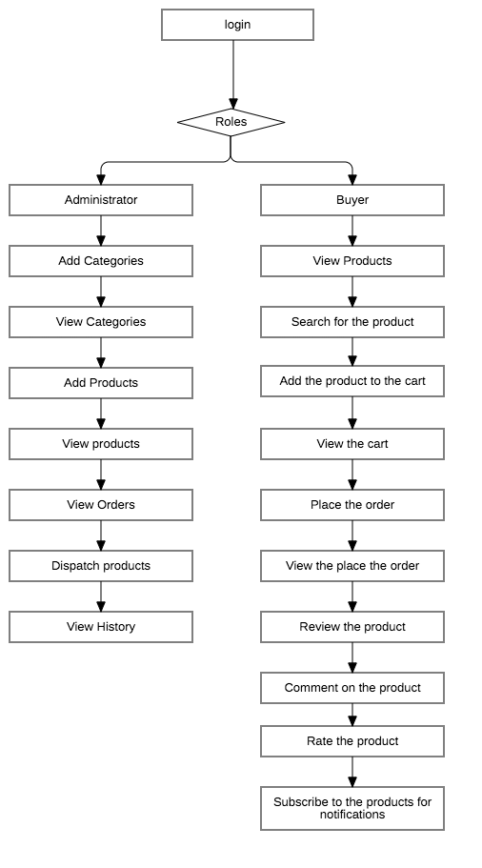

1.Home page of the online shopping website

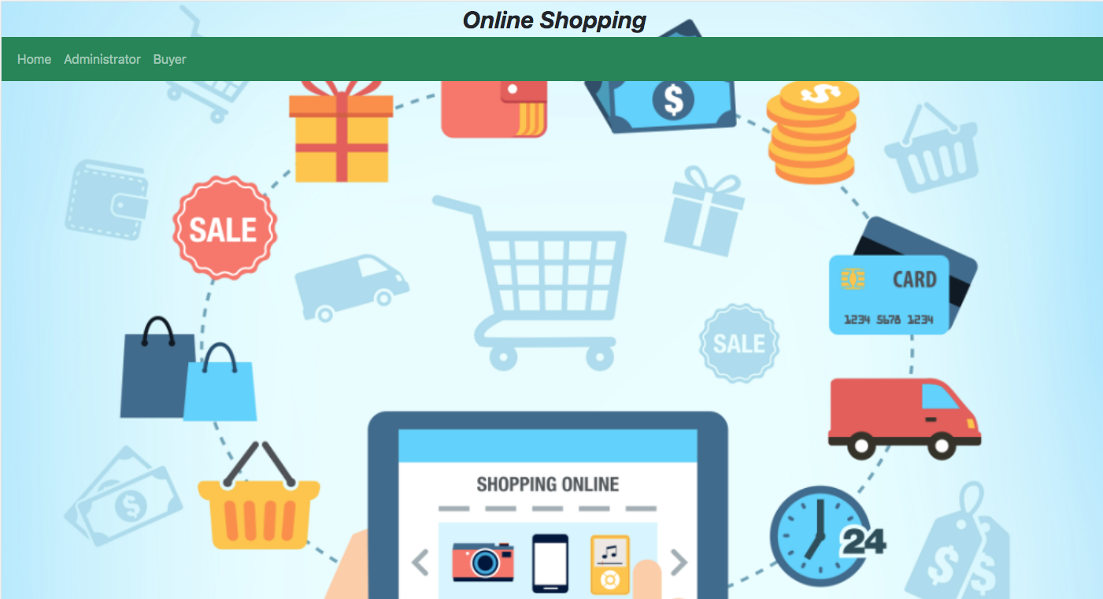

This is the home page of the online shopping website, by clicking on Administrator the administrator login will be redirected and in the same way by clicking on the Buyer the buyer login page will be redirected.

  2. Administrator login page

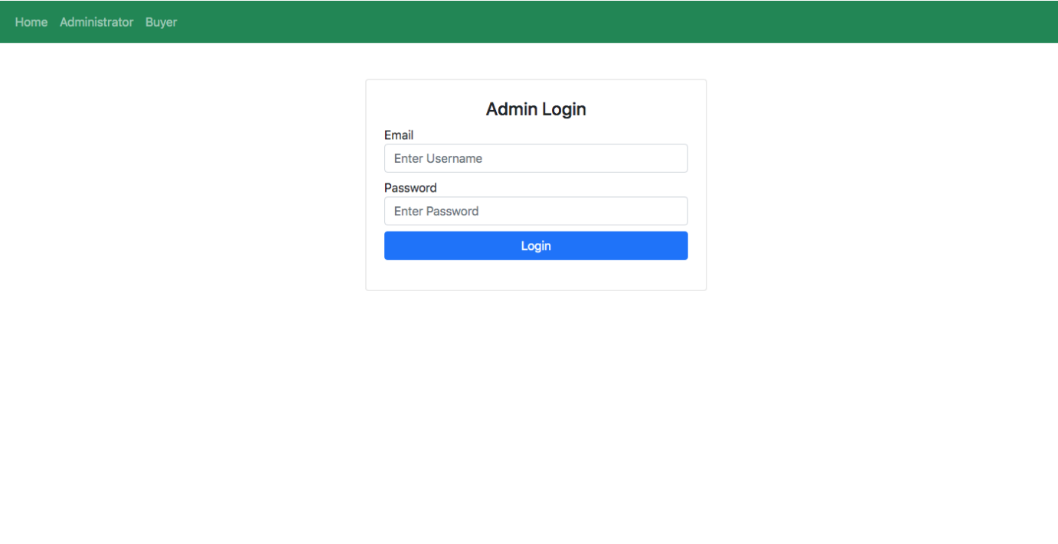

This is the administrator login page from which the administrator login and operate the operations. The admin will login with predefined credentials.

3. Administrator home page

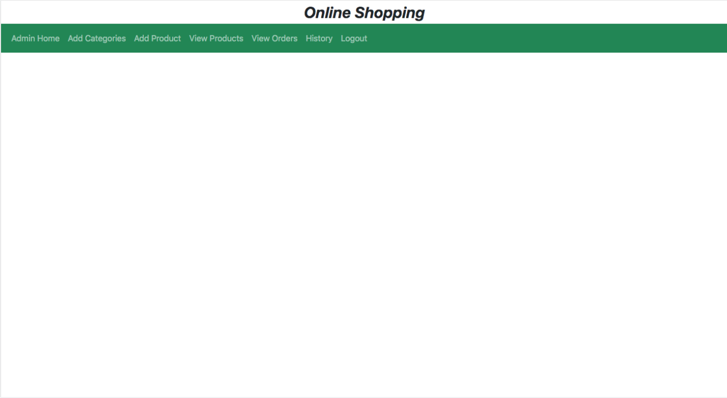

The administrator will perform all the operations from this page.

4. Add Categories

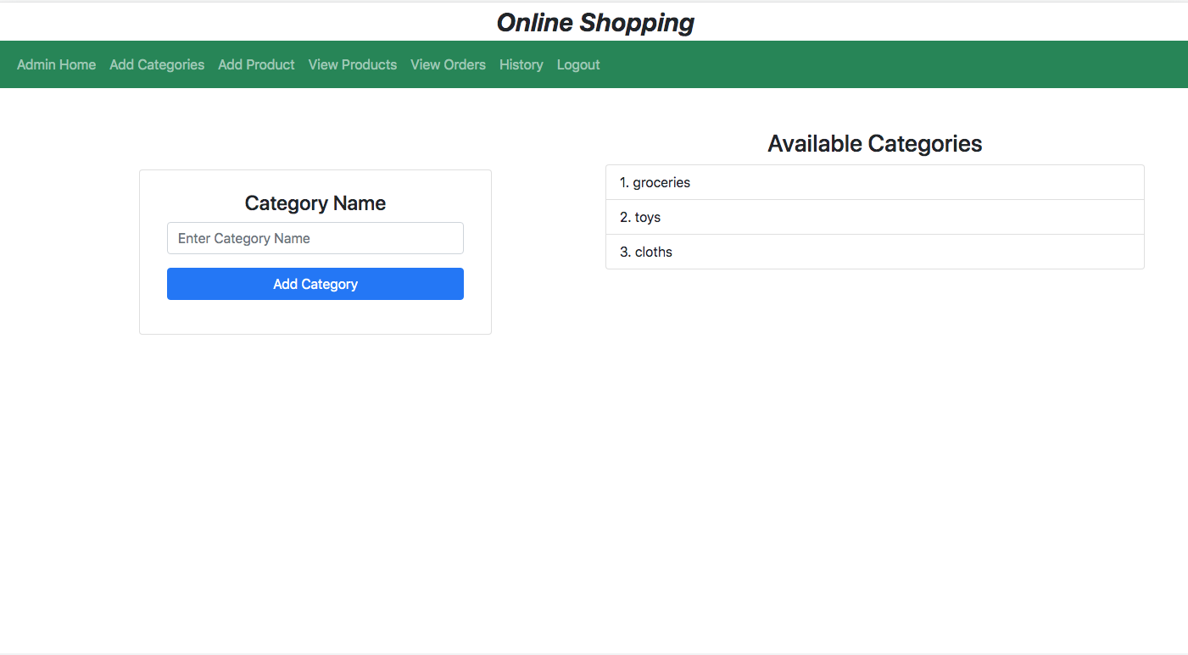

By clicking on the Add Category in the nav-bar the above page will appear and the administrator can add the categories and can view the available categories.

5. Add Products

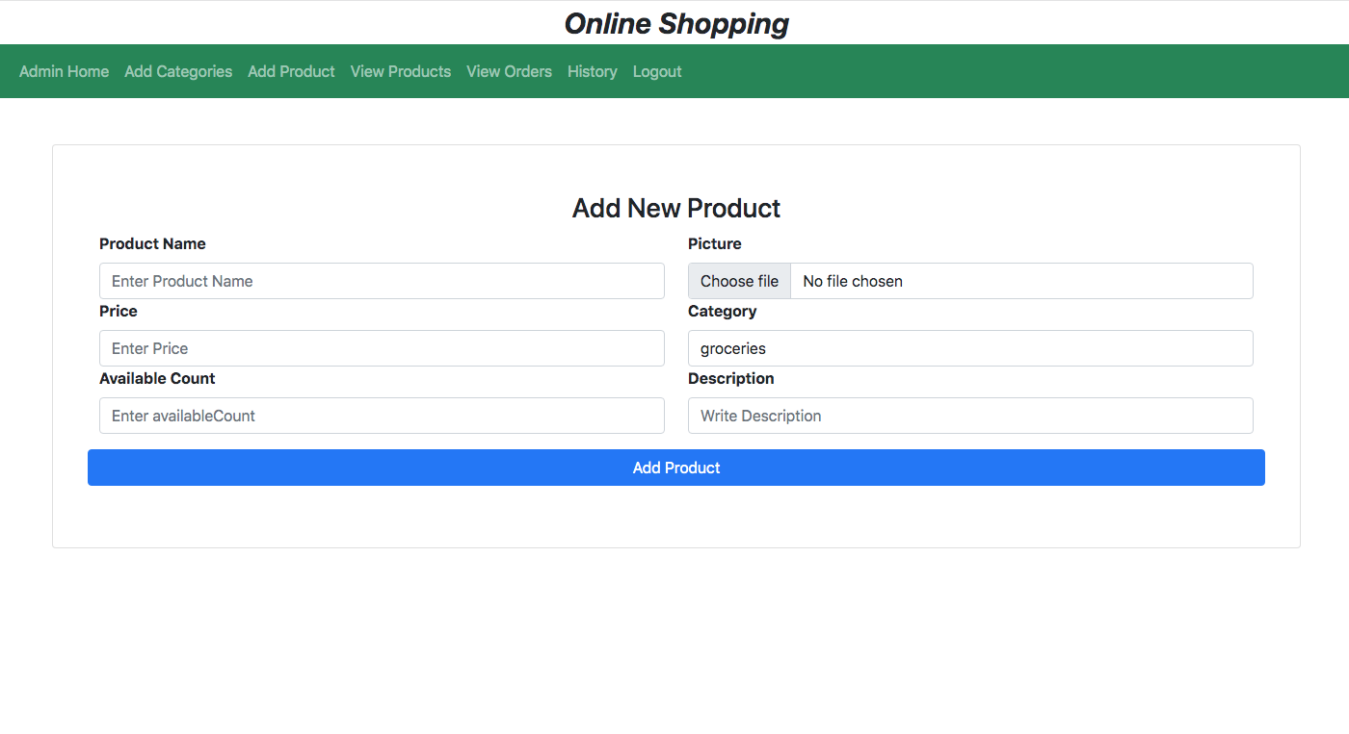

The administrator will add products by clicking on the Add Products in the nav-bar the above page will appear and the administrator can add the Products.

6. View Products

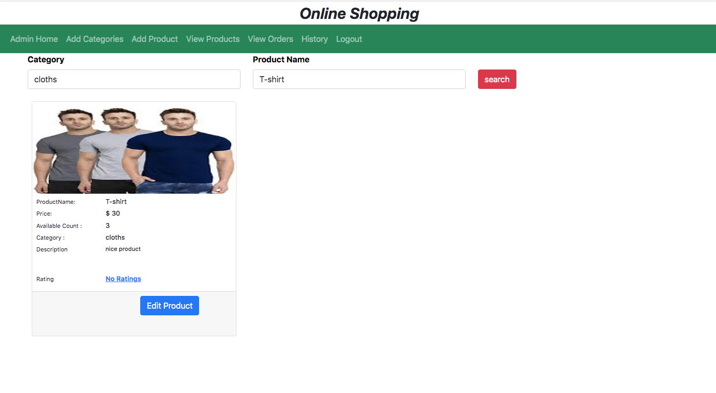

The administrator can view the added products by clicking on the View products in the nav-bar. The administrator can search the products which were added and can also edit the product details.

7. View Orders

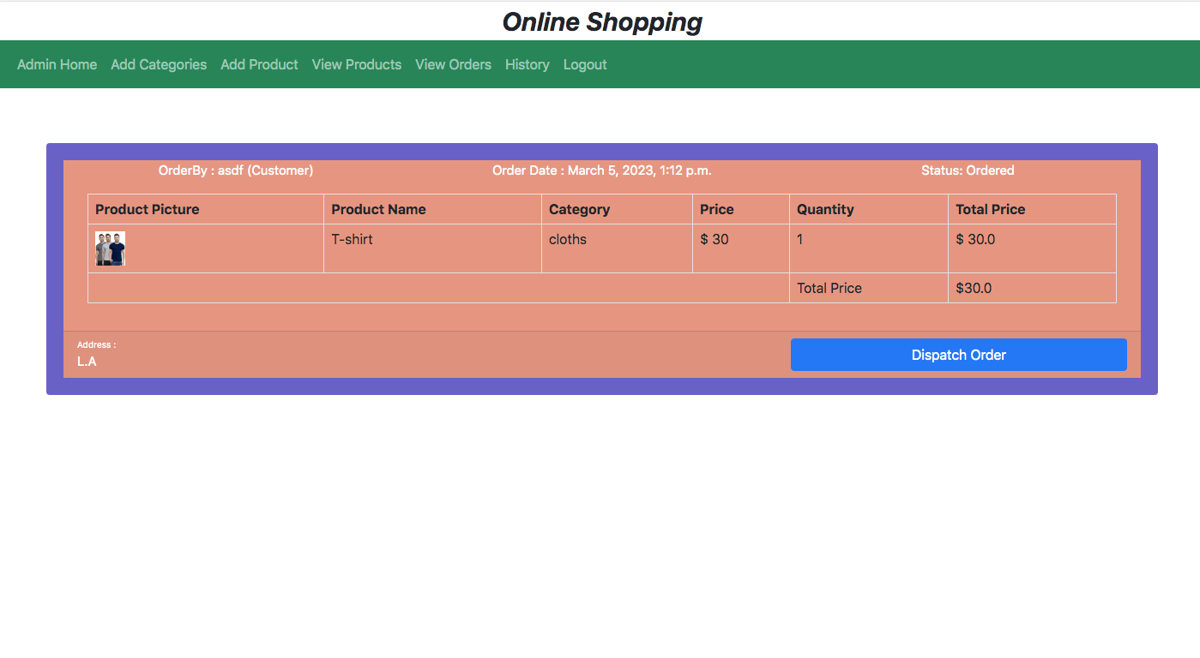

In this page the administrator can view the products orders and the status of the orders.

8. History

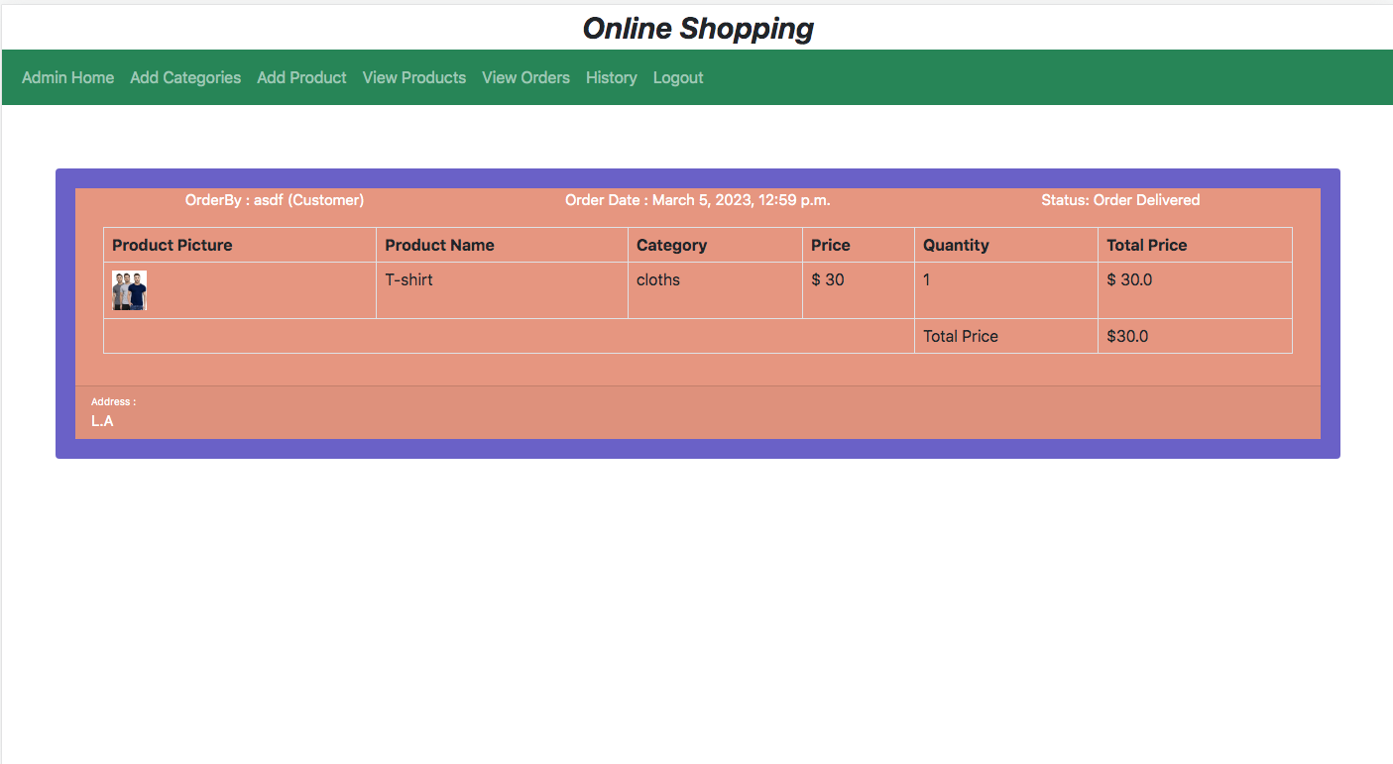

In this page the administrator can view the history about the order delivered.

9. Buyer login page

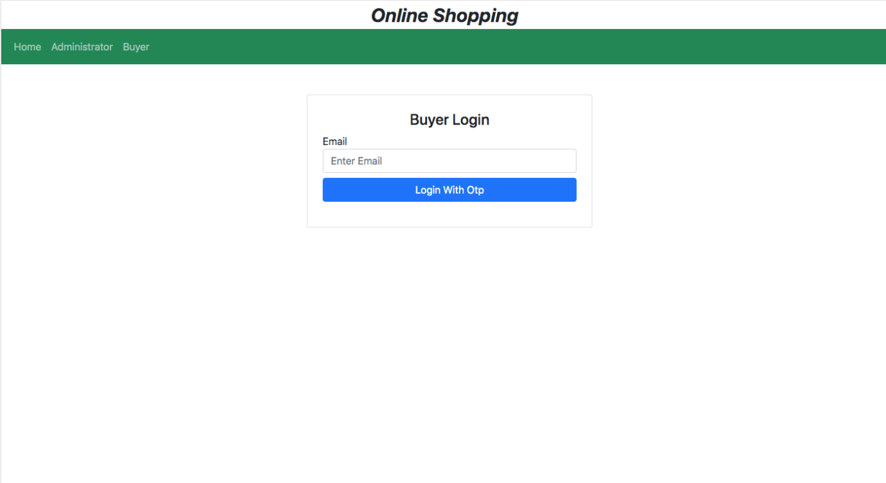

This is the buyer login page from which the buyer logs in and operates the operations. The buyer will login with email.

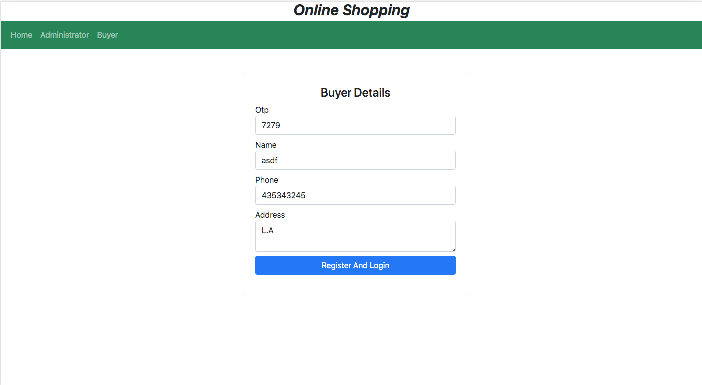

After clicking on the login with the otp button, the above will be redirected, enter the otp and register and login.

10. Buyer Home Page

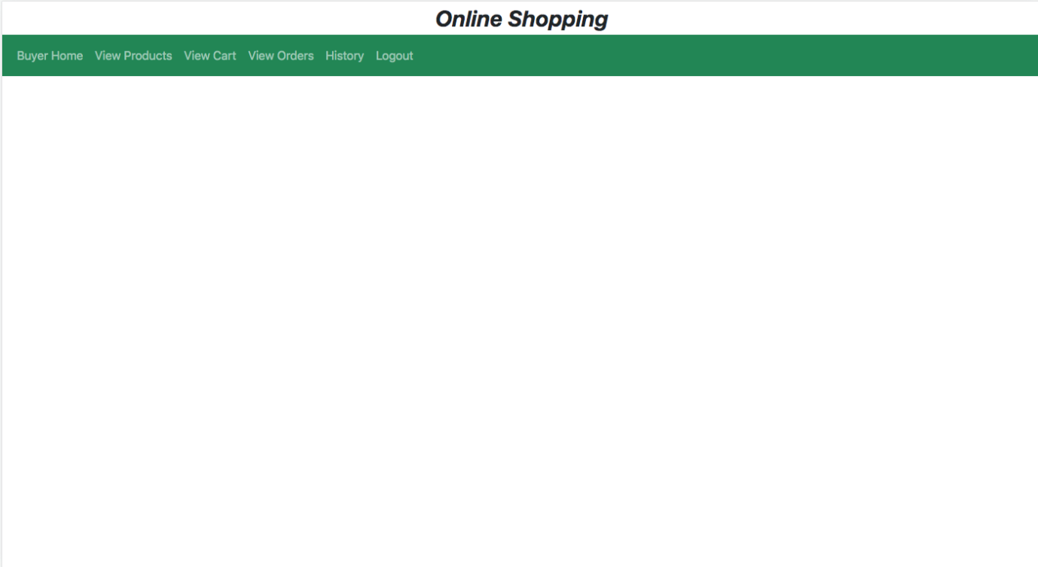

The buyer will perform the all operation from this page.

11. View Products

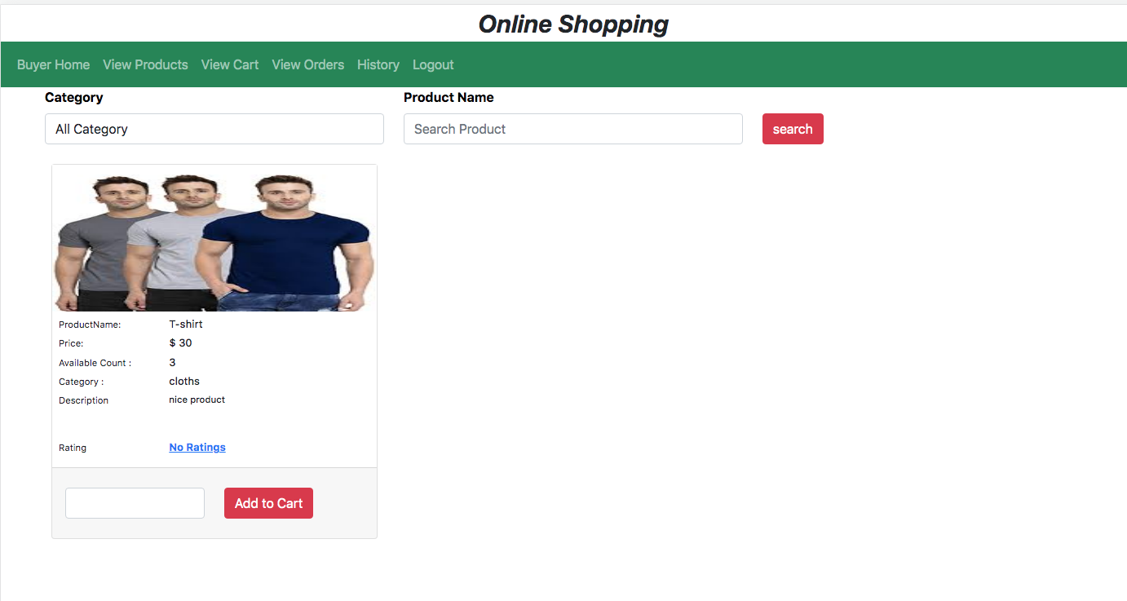

The buyer can view the added products by clicking on the View products in the nav-bar. The buyer can search the products, enter the quantity and add to cart.

12. View Cart

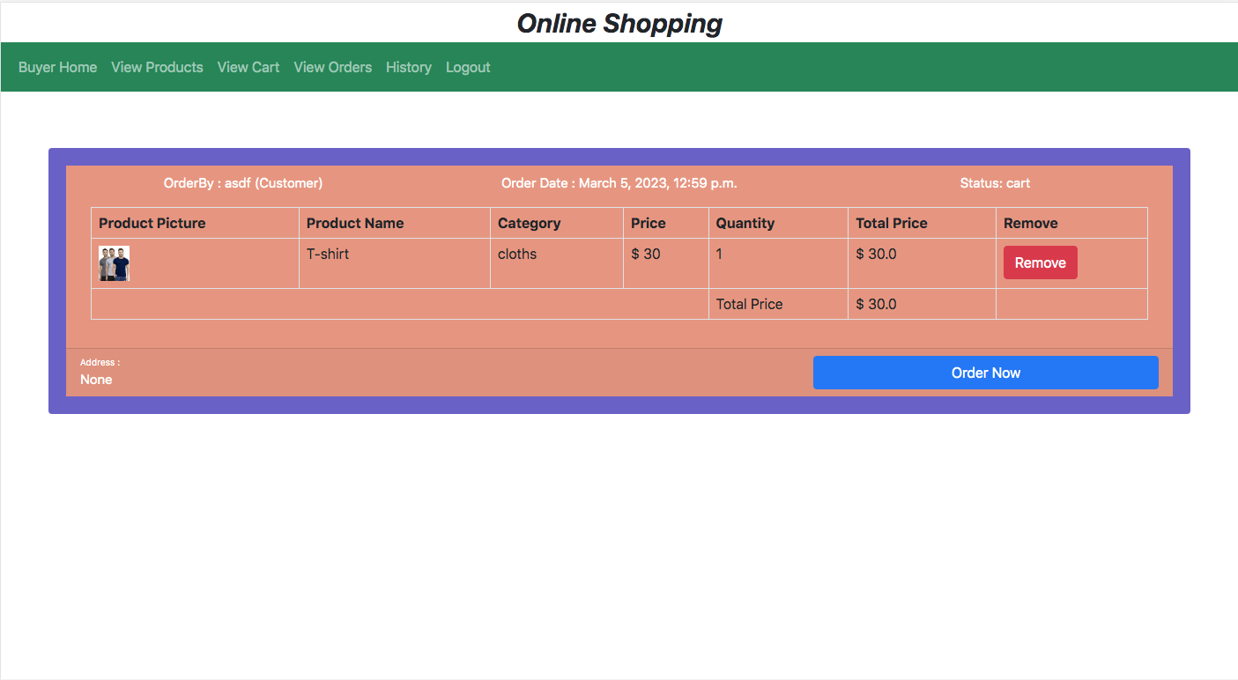

The buyer can view the cart and the products added to cart. The buyer can order the products in the cart or remove the products from the cart.

13. View Orders

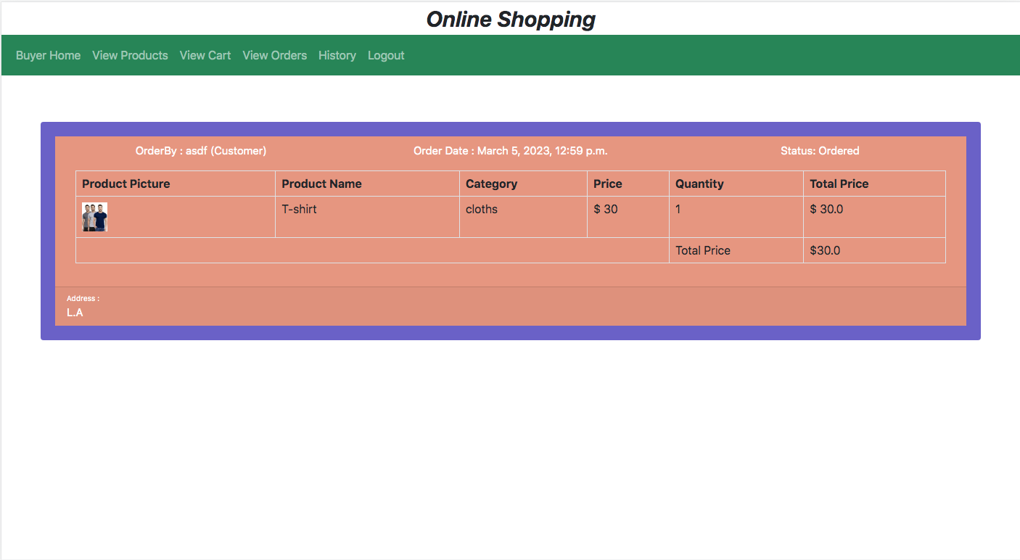

The buyer can view the placed orders by clicking on the view order in the nav-bar and can view the status of the orders.

14. History

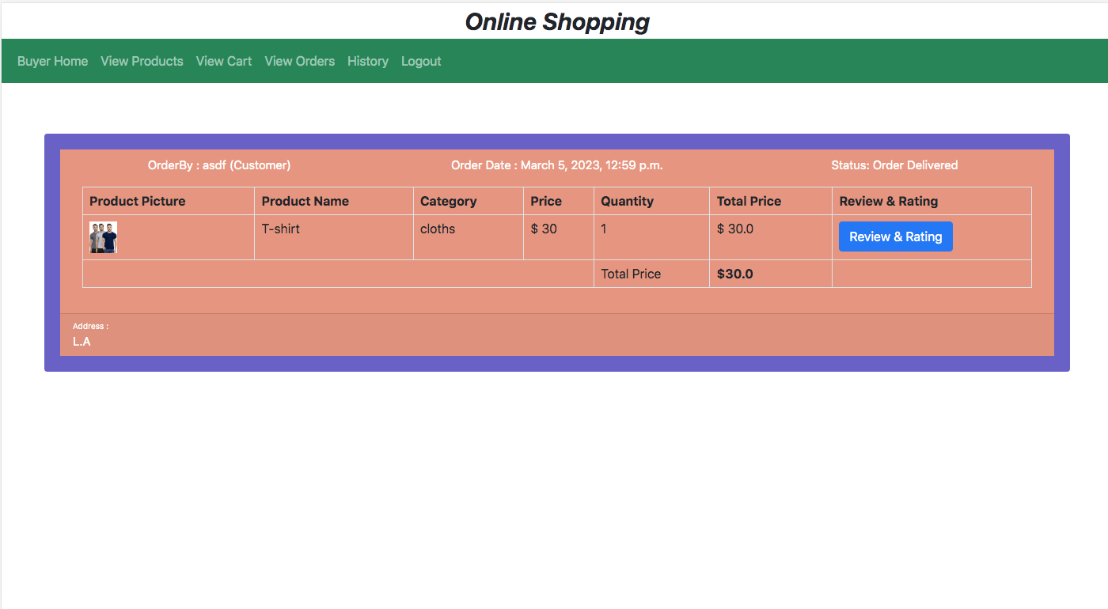

The buyer can view the received orders history and the review and rate the products.